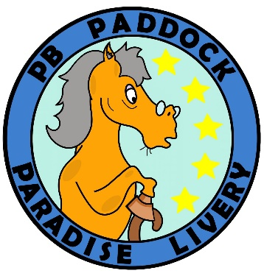
Health Checklist

This health checklist is simply to give us an idea of your horse’s current health status. This in no way impacts your likelihood of being accepted as a livery, so please complete the checklist to the best of your ability.

Once completed, please send it back to us at info@pbpaddockparadiselivery.com.

If you have any issues completing the checklist, please contact us directly.

Does your horse currently have or is prone to…

Skin & Allergies
☐ Mudfever
☐ Sunburn
☐ Sweet itch
☐ Rain scald
☐ Poor quality coat
☐ Allergies
☐ Coughing
☐ Excessive itching

Anxiety & Behaviour
☐ Excessive spooking
☐ Separation anxiety
☐ Head shaking
☐ Wind sucking
☐ Difficulty being caught
☐ Shies away when being approached
☐ Abnormally twitchy when being touched
☐ Girthy – reaches around to bite when being saddled
☐ Easily anxious
☐ Bargy around horses or people
☐ Explosive behaviour in hand
☐ Explosive behaviour under saddle
☐ Food guarding issues
☐ Crib biting
☐ Excessive rubbing of nose on leg or ground

Body & Feet
☐ Tight hamstrings
☐ Short, choppy strides
☐ Thrush - ongoing or repetitive
☐ Seedy toe
☐ Reoccurring abscesses
☐ Messy seasons
☐ Overly hormonal mare
☐ Reoccurring event lines down the outer hoof wall
☐ Cracks and splits in hoofs
☐ Swollen sheath or udders
☐ Puffiness around the eyes
☐ Cresty neck
☐ Fat pads above the tail or over the bottom
☐ Fat pads over the shoulders
☐ Overweight or obese
☐ Underweight
☐ Lacks muscle

